**( HTML ASSIGNMENT )**

**{ MODULE-1}**

**1. Are the HTML tags and elements the same thing?**

No, both are different things

 HTML Tags :

HTML tags are used to hold the HTML element.

HTML tag starts with < and ends with >

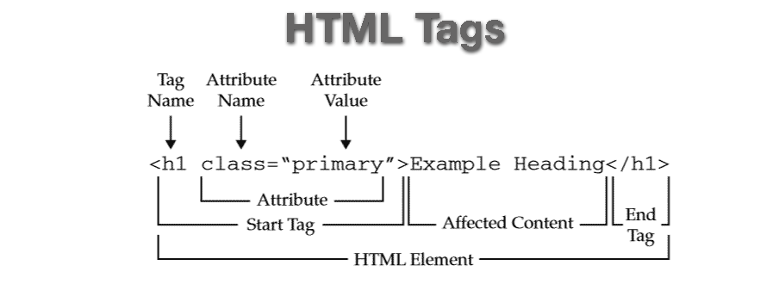

HTML Elements :



HTML element holds the content.

Whatever written within a HTML tag are HTML elements.

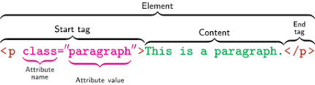

**2.What are tags and attributes in HTML ??**

Tags and attributes are the basis of HTML.

**Tag**

Tags are used to mark up the start of an HTML element and they are usually enclosed in angle brackets. An example of a tag is: <h1>.

Most tags must be opened <h1> and closed </h1> in order to function.

**Attribute**

“HTML attributes” are the modifier of the html elements or tags. Simply put, attributes are special words that provide additional information about the elements or attributes.

<img src="mybike.jpg" alt="A photo of my bike.">

In this instance, the image source (src) and the alt text (alt) are attributes of the <img> tag.

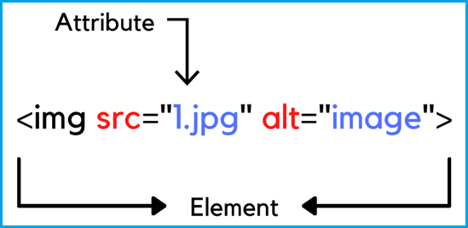

**3. What are void elements in HTML?**

There is a special group of elements that only have start tags and does not contain any content within it, these elements are called void elements. Void elements doesn’t have ending tags and can only have attributes but do not contain any kind of content.

*Example :*

<br>, <hr>, <img>, <input>, <link>, <base>, <meta>, <param>, <area>,

<embed>, <col>, <track>, <source>

**4.What are HTML Entities?**

An **HTML entity** is used to display invisible characters and reserved characters that would otherwise be interpreted as HTML code. It is a piece of text, or string, that begins with an ampersand (&) and ends with a semicolon (;).

*Example :*

&#128512; for smile emoji

&#60; for less than (<)

&#60; for greater than (>)

**5. What are different types of lists in HTML?**

HTML Lists are used to specify lists of information. All lists may contain one or more list elements.

 List are good from a structural point of view as they help create a well – structured ,more accessible , easy to maintain document.

**There are three different types of HTML lists:**

* Ordered List or Numbered List (ol)
* Unordered List or Bulleted List (ul)
* Description List or Definition List (dl)

1.) Ordered list :

**<ul>**

**<li>**Delhi**</li>**

**<li>**Gujarat**</li>**

**<li>**Rajastan**</li>**

**<li>**Madhya pradesh**</li>**

**</ul>**

Output :

1. Delhi
2. Gujarat
3. Rajastan
4. Madhya Pradesh

2.) Unordered list :

**<ul>**

**<li>**Delhi**</li>**

**<li>**Gujarat**</li>**

**<li>**Rajastan**</li>**

**<li>**Madhya pradesh**</li>**

**</ul>**

Output :

* Delhi
* Gujarat
* Rajastan
* Madhya Pradesh

3.) Description List or Definition List list :

**<dl>**

**<dt>**Delhi**</dt>**

**<dd>** capital of india **</dd>**

**<dt>**Gujarat**</dt>**

**<dd>** Gujarat is the Westernmost state of India**</dd>**

**<dt>**rajastan**</dt>**

**<dd>**-rajastan is a state in northen india.**</dd>**

**<dt>**Madhya pradesh**</dt>**

**<dd>**-MADHYA PRADESH is the central region of India it is also known as the ” heart of India .**</dd>**

**</dl>**

Output :

Delhi

- capital of india

Gujarat

- Gujarat is the Westernmost state of India

Rajastan

- rajastan is a state in northen india

Madhya pradesh

- MADHYA PRADESH is the central region of India it is also known as the ” heart of India.

**6.What is the ‘class’ attribute in HTML?**

The class attribute **specifies one or more classnames for an element**. The class attribute is mostly used to point to a class in a style sheet. However, it can also be used by a JavaScript (via the HTML DOM) to make changes to HTML elements with a specified class.

*Example :*

<html>

<head>

<style>

h1.intro

{

color: blue;

}

p.important

{color: green;

}

</style>

</head>

<body>

<h1 class="intro">Header 1</h1>

<p>A paragraph.</p>

<p class="important">Note that this is an important paragraph. :)</p>

</body>

</html>

**7. What is the difference between the ‘id’ attribute and the ‘class’ attribute of HTML elements**?

The only difference between them is that **“id” is unique in a page and can only apply to at most one element, while “class” selector can apply to multiple elements**.

*Example :*

**1, Id.html**

!DOCTYPE html>

<html>

<head>

<title> Id demo

</title>

<style> #idDemo{

color:green; font-size:25px;

}

</style>

</head>

<body style="text-align:center">

<h1>Get element by Id</h1>

<p id="idDemo">Demo for Id selector</p>

</body>

</html>

**2. Class.html**

<!DOCTYPE html>

<html>

<head>

<title> Class demo

</title>

<style>

.classDemo{ color:orange; font-size:25px;

}

</style>

</head>

<body style="text-align:center">

<h1>Get element by class</h1>

<p class="classDemo">Demo for class selector</p>

</body>

</html>

1. **What are the various formatting tags in HTML?**

HTML facilitates the ability for formatting text just like we do in MS Word or any text editing software.

* <b> - Bold text
* <strong> - Important text
* <i> - Italic text
* <em> - Emphasized text
* <mark> - Marked text
* <small> - Smaller text
* <del> - Deleted text
* <ins> - Inserted text
* <sub> - Subscript text
* <sup> - Superscript text

1. **How is Cell Padding different from Cell Spacing** **?**

* Cell padding

Cellpadding basically defines the space present between a table cell's border and the content present in it. Also It deals with a single cell.

* Cell spacing

Cellspacing basically defines the space present between individual adjacent cells. Also it deals with multiple (more than one) cell.

**Cell padding example :**

<!DOCTYPE html>

<**html**>

<**head**>

    <**style**>

        table,

        th,

        td {

            border: 2px solid green;

            text-align: center;

        }

        th,

        td {

            padding: 12px;

            background-color: none;

        }

        h1 {

            color: green;

        }

    </**style**>

</**head**>

<**body**>

    <**center**>

        <**h1**>GeeksforGeeks</**h1**>

        <**h2**>Cell Padding property</**h2**>

        <**h3**>padding: 12px;</**h3**>

        <**table** style="width:70%">

            <**tr**>

                <**th**>Firstname</**th**>

                <**th**>Lastname</**th**>

                <**th**>Age</**th**>

            </**tr**>

            <**tr**>

                <**td**>Sravan</**td**>

                <**td**>kumar</**td**>

                <**td**>22</**td**>

            </**tr**>

            <**tr**>

                <**td**>Harsha</**td**>

                <**td**>vardhan</**td**>

                <**td**>21</**td**>

            </**tr**>

        </**table**>

    </**center**>

</**body**>

</**html**>

**Output**

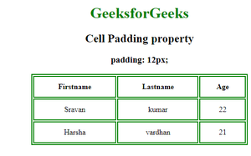

**Cell spacing example :**

< ! DOCTYPE html>

<**html**>

<**head**>

    <**style**>

        table,

        th,

        td {

            border: 2px solid green;

            text-align: center;

        }

        h1 {

            color: green;

        }

    </**style**>

</**head**>

<**body**>

    <**center**>

        <**h1**>GeeksforGeeks</**h1**>

        <**h2**>Cell Spacing property</**h2**>

        <**h3**>cellspacing = "20px"</**h3**>

        <**table** style="width:70%;"

            cellspacing="20px">

            <**tr**>

                <**th**>Firstname</**th**>

                <**th**>Lastname</**th**>

                <**th**>Age</**th**>

            </**tr**>

            <**tr**>

                <**td**>sravan</**td**>

                <**td**>kumar</**td**>

                <**td**>22</**td**>

            </**tr**>

            <**tr**>

                <**td**>harsha</**td**>

                <**td**>vardhan</**td**>

                <**td**>21</**td**>

            </**tr**>

        </**table**>

    </**center**>

</**body**>

</**html**>

**Output :**



**10.How can we club two or more rows or columns into a single row or column in an HTML table?**

To merge cells in HTML,

use the colspan and rowspan attribute.

The rowspan attribute is for the number of rows a cell should span,

The colspan attribute is for a number of columns a cell should span.

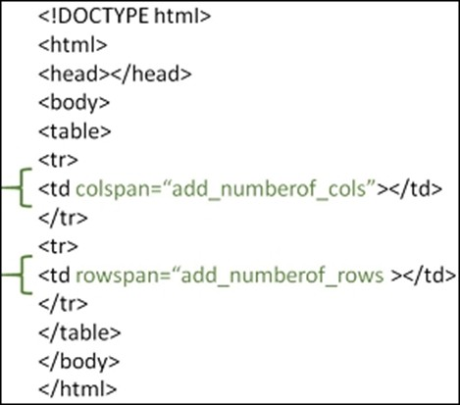

**11.** **What is the difference between a block-level element and an inline element?**

# Inline elements do not force a new line to begin in the document flow.

**Block elements, on the other hand, typically cause a line break to occur** (although, as usual, this can be changed using CSS).

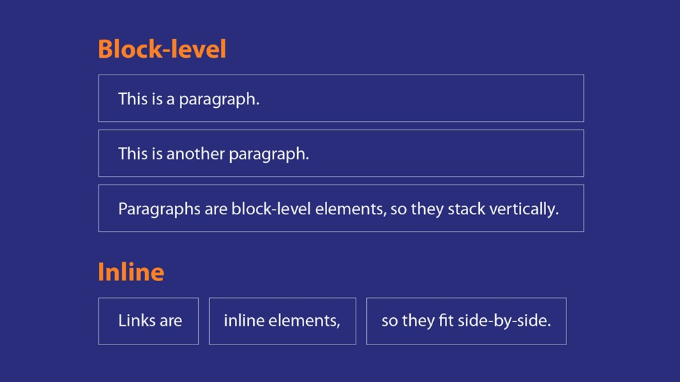

**12 How to create a Hyperlink in HTML?**

To make a hyperlink in an HTML page, **use the <a> and**

**</a> tags**, which are the tags used to define the links. The <a> tag indicates where the hyperlink starts and the

# 13 What is the use of an iframe tag?

The <iframe> tag **specifies an inline frame**. An inline frame is used to embed another document within the current HTML document.

<iframe src="https://[www.google.com](http://www.google.com/)" title="Practicals"></iframe>

# 14 What is the use of a span tag? Explain with example?

The <span> tag is an inline container used to mark up a part of a text, or a part of a document.

<p>Hello <span style="color:blue"> Good </span> morning.</p>

The <span> tag is an inline container used to mark up a part of a text, or a part of a document.

<p>Hello <span style="color:blue"> Good </span> morning.</p>

**15 How to insert a picture into a background image of web page?**

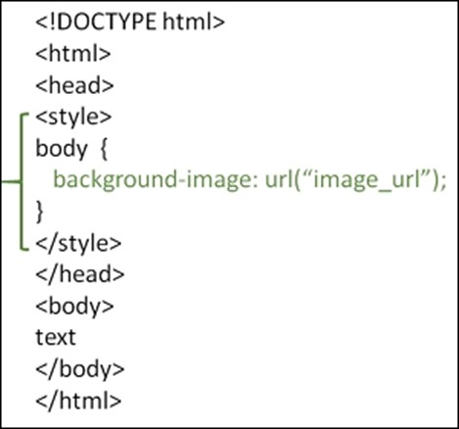

***16* How are active links different from normal links?**

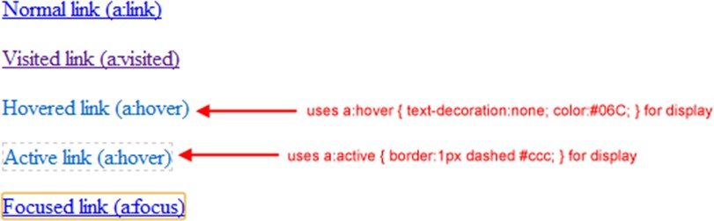

**17 What are the different tags to separate sections of text?**

<br> tag – Usually <br> tag is used to separate the line of text. It breaks the current line and conveys the flow to the next line.

<p> tag – This contains the text in the form of a new paragraph.

<blockquote> tag – It is used to define a large quoted section.

# What is SVG?

SVG stands for Scalable Vector Graphics.

SVG defines vector-based graphics in XML format. SVG defines the graphics in XML format

* + Every element and every attribute in SVG files can be animated
  + SVG is a W3C recommendation
  + SVG integrates with other W3C standards such as the DOM and XSL

<html>

<body>

<h1>My first SVG</h1>

<svg width="100" height="100">

<circle cx="50" cy="50" r="40" stroke="green" stroke-width="4" fill="yellow" />

</svg>

</body>

1. **What is differene between HTML an d XHTML?**

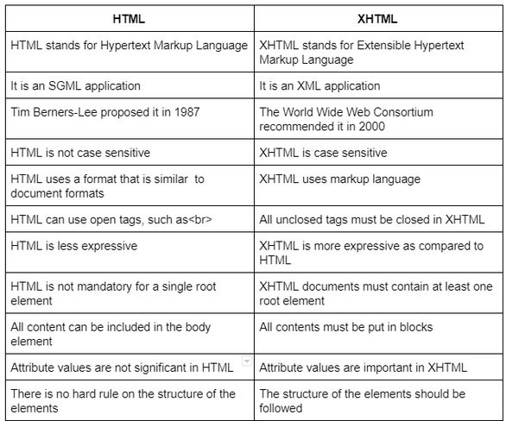

1. **What are logical and physical tags in HTML? Logical tags describe the behavior**

Physical tags are used to decide the appearance of the text and do not provide any information about the text.

